**CA4009 Search Technologies Lab #4 & 5**

**Date:** 02/12/2019

**Name(s):** Maksims Kompanijecs - 15306971, Matthew Farelly - 15366246

**4.Experimenting with Query Expansion in IR**

Query topic from TREC collection selected: 360 - drug legalization benefits

Using BM25 ranking functions weighing terms were **b = 1.2** and **k = 0.75**

The documents retrieved were as follows:

|  |  |  |
| --- | --- | --- |
|  | Article | Description |
| **1** | **LA031289-0044** | article from March 12, 1989 about drug epidemic, stating that is time to legalize drugs and sell them in government controlled stores |
| **2** | **LA032590-0032** | article from March 25, 1990 about drug decriminalization in America and how it is the worst from of drug control |
| **3** | **FBIS4-57566** | article from 14 May 1994 on how Law 1008 has achieved achieved good results and met its goal of struggling against drug trafficking |
| **4** | **FBIS4-67248** | article from 14 May 1994 about ATIN AMERICA BOLIVIA Soliz Agrees With U.S. Ambassador on Drug Law |
| **5** | **FBIS3-9970** | article from 28 Feb 1994 detailing Interview with Colombian Prosecutor General Gustavo de Greiff about progress was toward the surrender of Cali Cartel members |
| **6** | **FBIS3-21631** | article from 28 February 1994 about surrender of Cali Cartel members and details in which prison where they will stay |
| **7** | **LA112089-0024** | article from November 20, 1989 detailing forms of controlled legalization of drugs by George P. Shultz, |
| **8** | **LA031990-0020** | article from March 19, 1990 about drug dealing and how it offers powerful economic incentives for the young |
| **9** | **FT931-16994** | article from 04 JAN 93 about bell tolls for drugs harmony |
| **10** | **FR940112-2-00078** | article from N/A about how claimant applied for disability benefits under the supplemental security income program |

**Calculating ow(i) values for terms that appear in the known relevant documents**

I wrote a Python script that would calculate ow(i) and rw(i) value based on the most significant terms that I have selected. This saved me a lot of time having to calculate ow(i) and rw(i) values manually.

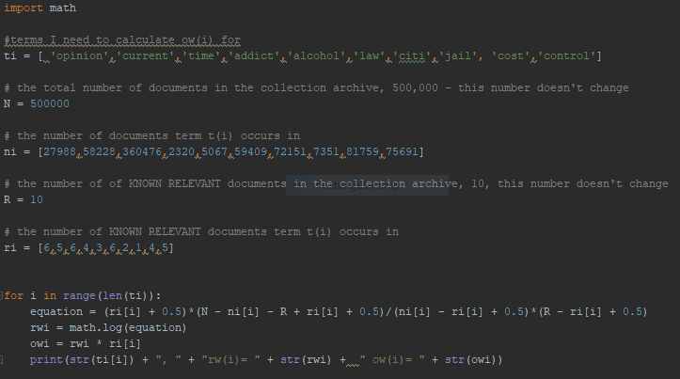

These are the rw(i) and ow(i) values generated from the script above.

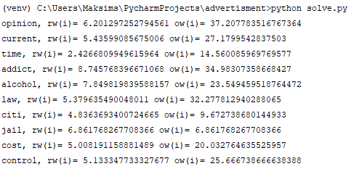

Table including **rw(i)** and **ow(i)** for the most significant terms present in the top 10 documents based on ‘**drug legalization benefits**’ query.

|  |  |  |  |  |
| --- | --- | --- | --- | --- |
| **term - t(i)** | **r(i) out of 10** | **n(i)** | **rw(i)** | **ow(i)** |
| opinion | 6 | 27988 | 6.20129725279 | 37.2077835168 |
| current | 5 | 58228 | 5.43599085675 | 27.1799542838 |
| time | 6 | 360476 | 2.42668099496 | 14.5600859698 |
| addict | 4 | 2320 | 8.74576839667 | 34.9830735867 |
| alcohol | 3 | 5067 | 7.84981983959 | 23.5315593372 |
| law | 6 | 59409 | 5.37963549005 | 32.2778129403 |
| citi | 2 | 72151 | 4.83636934007 | 9.67241475033 |
| jail | 1 | 7351 | 6.86176826771 | 6.86176826771 |
| cost | 4 | 81759 | 5.00819115888 | 20.0327646355 |
| control | 5 | 75691 | 5.13334773333 | 25.6667386666 |

Based on my calculated ow(i) values. I added some of these terms to my original query - **drug legalization benefits** to see how the ranked

retrieval list has changed. For the purpose of this exercise I have selected the following terms to carry out query expansion.

1. jail
2. addict , law
3. cost, control, alcohol

|  |  |  |  |
| --- | --- | --- | --- |
| **Original query top 10** | **Original query + “jail” top 10 documents** | **Original query + “addict”, “law” top 10 documents** | **Original query + “cost”, “control”, “alcohol” top 10 documents** |
| **LA031289-0044** | **LA031289-0044** | LA032590-0031 | **LA031289-0044** |
| **LA032590-0032** | LA120289-0008 | **LA032590-0032** | LA031990-0019 |
| **FBIS4-57566** | LA091789-0139 | LA103189-0060 | FR940830-1-00101 |
| **FBIS4-67248** | LA120889-0165 | FBIS3-57998 | LA120889-0165 |
| **FBIS3-9970** | LA031990-0019 | FBIS3-60059 | LA120289-0008 |
| **FBIS3-21631** | LA031889-0016 | **LA031289-0044** | LA120289-0008 |
| **LA112089-0024** | LA072089-0022 | LA100889-0211 | LA011090-0127 |
| **LA031990-0020** | FR941017-1-00038 | FBIS4-45284 | LA091690-0032 |
| **FT931-16994** | LA020690-0100 | FBIS4-32836 | LA040389-0018 |
| **FR940112-2-00078** | LA040389-0018 | FBIS4-62695 | FR940208-2-00127 |

Using expanded queries with ‘**drug legalization benefits’** topic returned a lot of new documents. The only one that was consistent and seen within all of the expansion queries was article **LA031289-0044.** The same document also decreased in rank, when added some terms to it. Document **LA031289-0044** went from being number 1 in unexpanded query to number 6 when I added **‘law’** and **‘addict’** to the original query.

**Investigations using qrel data**

For this question I’ll examine the retrieved ranked list to identify if there any relevant documents based on the QREL. For the purpose of this question I’ll examine the original ‘**drug legalization benefits’** and - **‘drug legalization benefits’ ‘addict’ ‘law’** query retrieved lists against TREC qrel files.

**Original unexpanded query** (1 = relevant, 0 = not relevant)

|  |  |  |  |
| --- | --- | --- | --- |
| **Ranked results** | | **Relevant?** | |
|  | **“Drug”, “legalization”, “benefits”** | **BM25** | **qrel** |
| 1 | LA031289-0044 | 1 | 1 |
| 2 | LA032590-0032 | 1 | 1 |
| 3 | FBIS4-57566 | 0 | 0 |
| 4 | FBIS4-67248 | 0 | 0 |
| 5 | FBIS3-9970 | 0 | 1 |
| 6 | FBIS3-21631 | 0 | 1 |
| 7 | LA112089-0024 | 1 | 1 |
| 8 | LA031990-0020 | 0 | 1 |
| 9 | FT931-16994 | 0 | 0 |
| 10 | FR940112-2-00078 | 0 | 0 |

**Original unexpanded query + “addict”, “law”** (1 = relevant, 0 = not relevant)

|  |  |  |  |
| --- | --- | --- | --- |
| **Ranked results** | | **Relevant?** | |
|  | **“Drug”, “legalization”, “benefits”,”addict”,”law”** | **BM25** | **qrel** |
| 1 | LA032590-0031 | 1 | 1 |
| 2 | LA032590-0032 | 0 | 1 |
| 3 | LA103189-0060 | 0 | 0 |
| 4 | FBIS3-57998 | 1 | 1 |
| 5 | FBIS3-60059 | 1 | 1 |
| 6 | LA031289-0044 | 1 | 1 |
| 7 | LA100889-0211 | 0 | 1 |
| 8 | FBIS4-45284 | 0 | 0 |
| 9 | FBIS4-32836 | 0 | 0 |
| 10 | FBIS4-62695 | 0 | 0 |

From carrying out this exercise it was clear to see that expanding queries doesn’t always return more relevant results.